**INSTRUCTION MANUAL**

**SNAPSHOTS**

**HOMEPAGE**

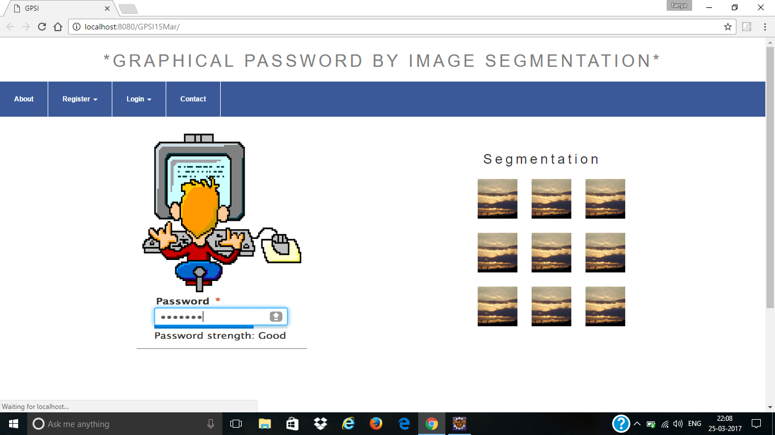

Fig. 6.1 Homepage

**USER REGISTRATION PAGE**

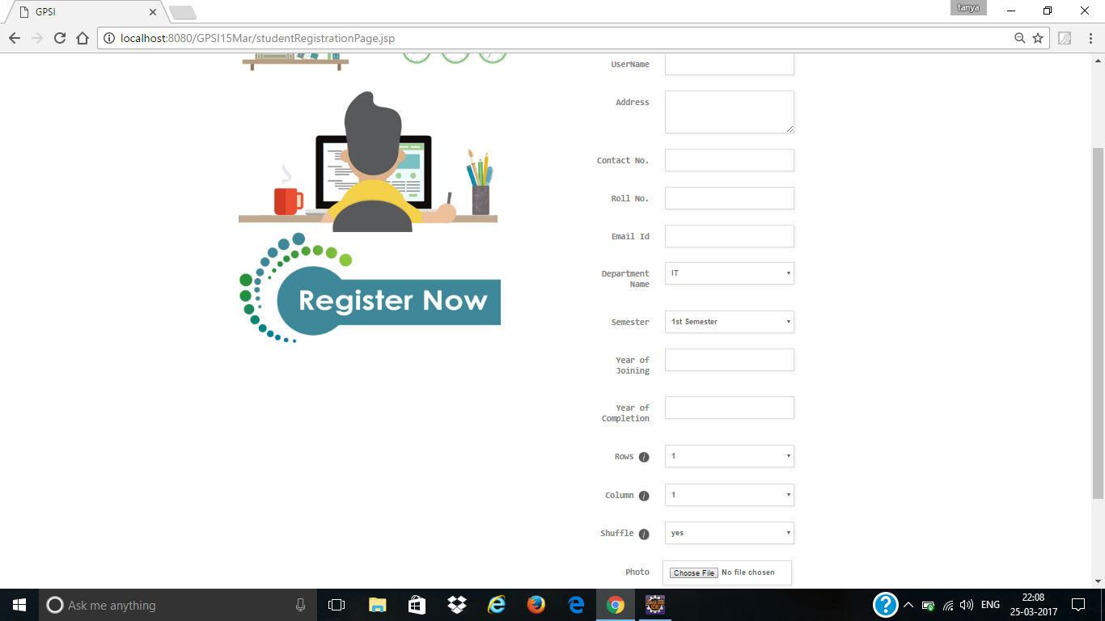

Fig. 6.2 User Registration Page

The figure 6.2 shows the registration form wherein the user have to give username and basic details and the user also specifies the grid size (rows and columns) of his image. Then the user has to specify whether the segments of the image should shuffle during login or not.

**SETTING PASSWORD DURING REGISTRATION**

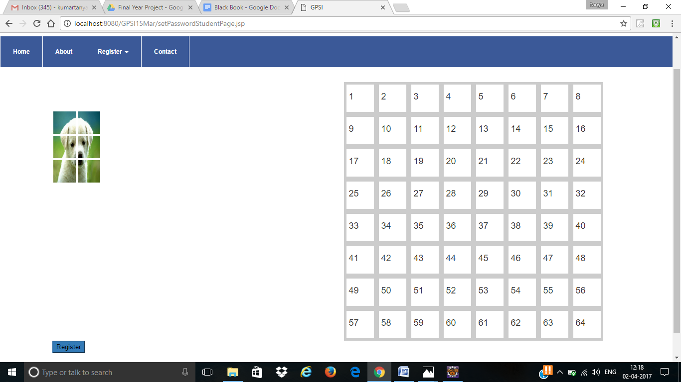

Fig. 6.3 Image segmented into user defined grid size

In Figure 6.3 the image will be presented to the user in segmented form. The grid size into which the image is segmented is defined by the user.

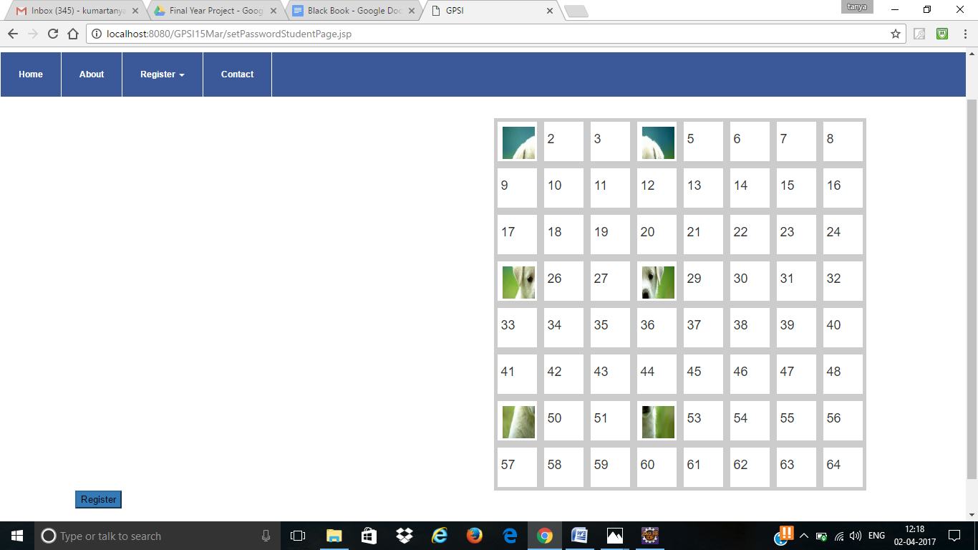

Fig. 6.4 Segments of image mapped into empty 8*8 grid

In figure 6.4 the user is asked to map each segment of the image onto the 8*8 empty grid. The sequence in which each segment is picked and position onto where its mapped will be noted and will act as the password during login.

**LOGIN**

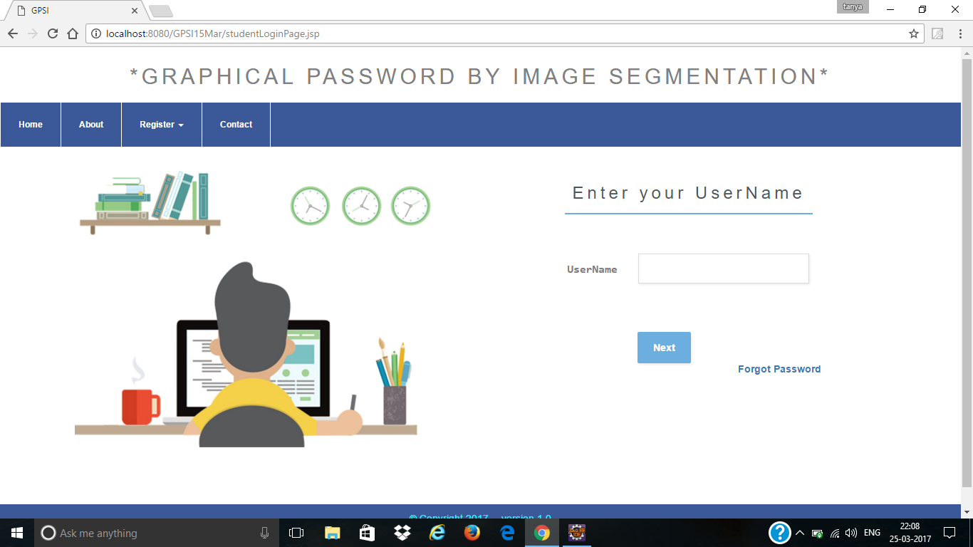

Fig. 6.5 Login page

The figure 6.5 is the login page wherein first the user has to give his username. If the username is correct then user will be redirected to another page where he will be presented with the segmented image and will be asked to map the segments of the image in correct sequence and position on the empty 8*8 grid.

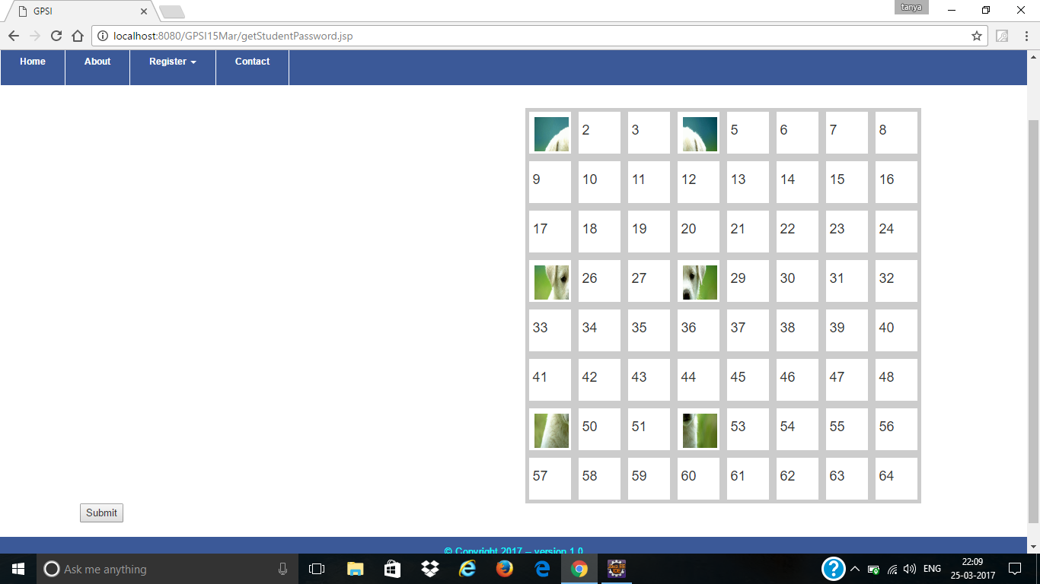

Fig. 6.6 Map segments in correct sequence and position

In figure 6.6 the segments of the image is mapped by the user onto the empty 8*8 grid. The sequence and position of each segments is verified and the user is authenticated.

**USER AUTHENTICATED FOR LMS**

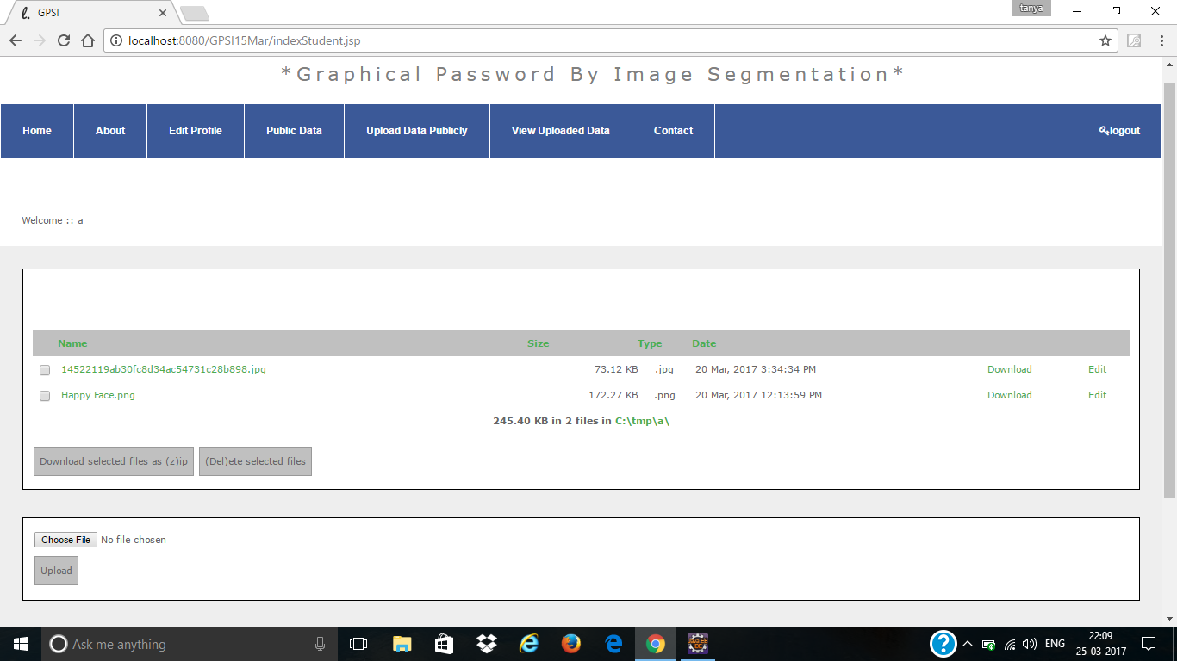

Fig. 6.7 LMS Application

In figure 6.7 once the user is authenticated, he gets access to LMS.

**6.1.6 UPLOAD DATA PUBLICALLY**

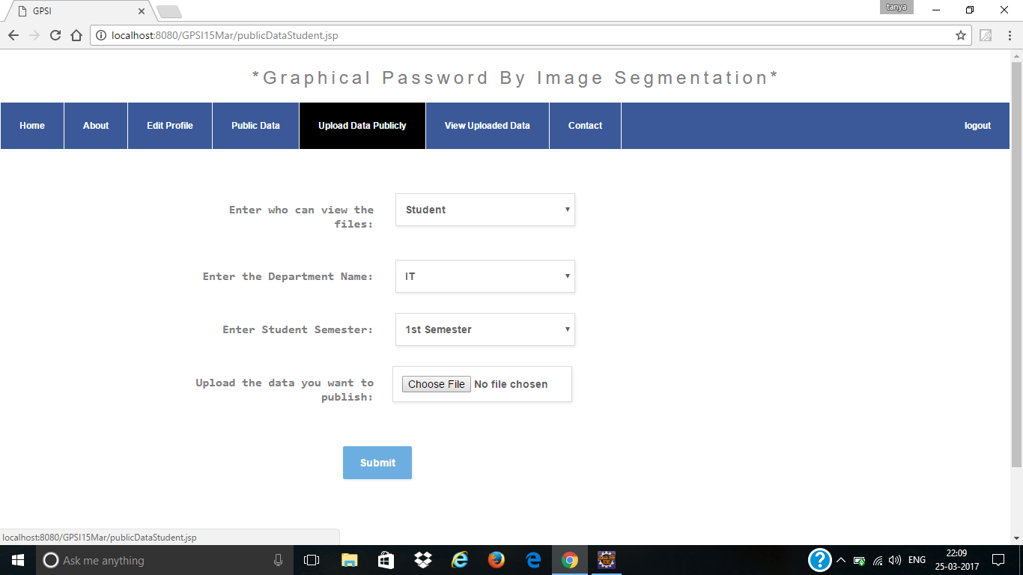

Fig. 6.8 Upload data publically

In figure 6.8 the user can grant access to other users to view and download the data.

**VIEW AND DOWNLOAD DATA**

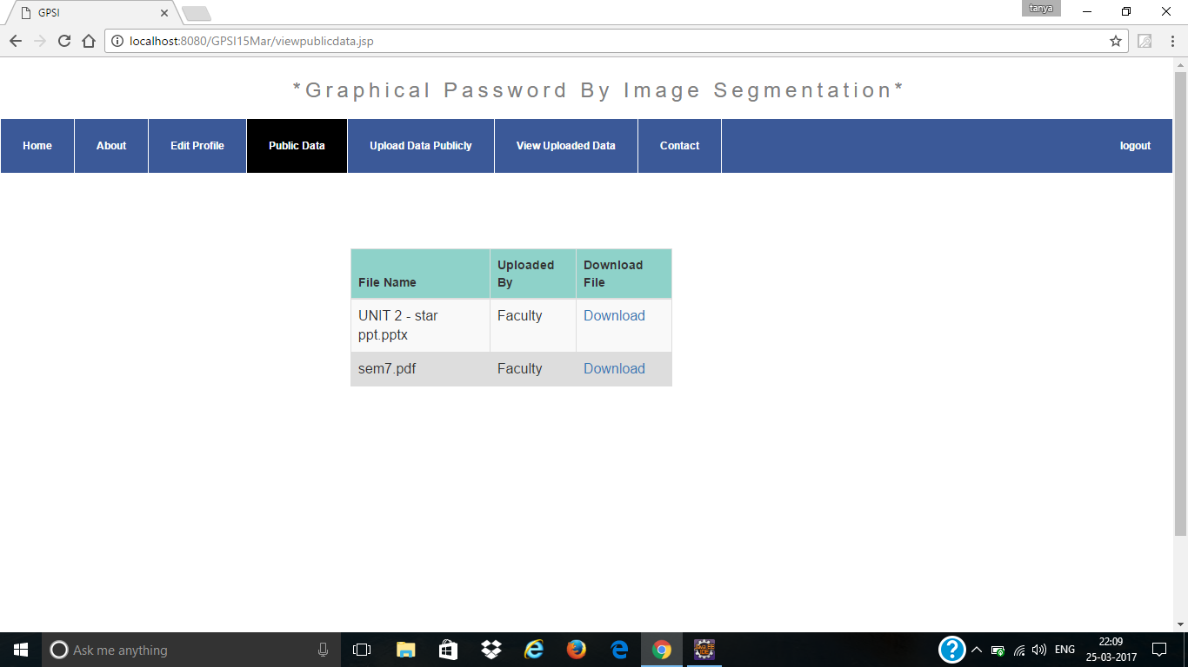

Fig. 6.9 View and download public data

In figure 6.9 shows the files that this user is given access to by other users. The user can view and download this file.

**FORGOT PASSWORD**

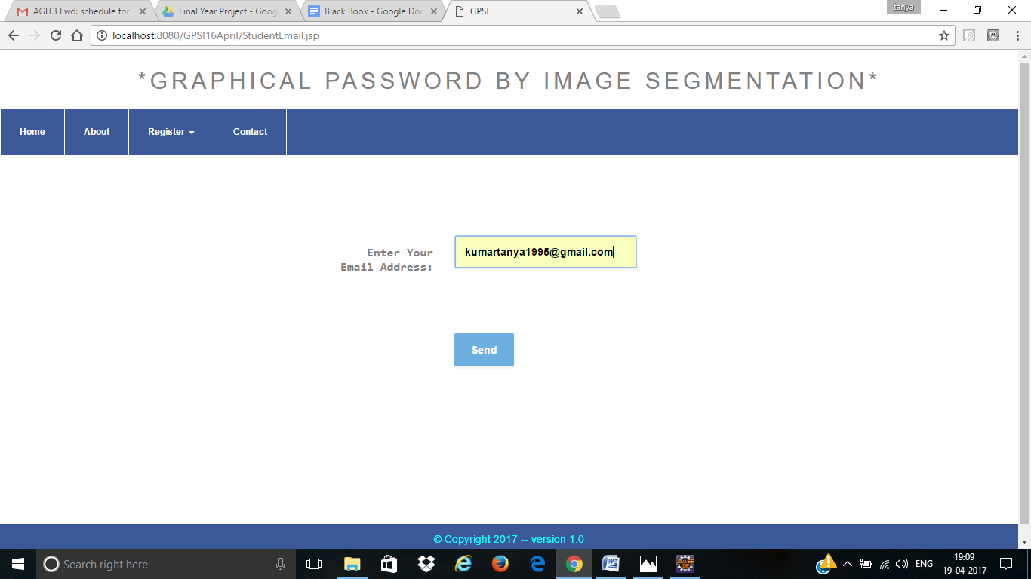

Fig. 6.10 User enters registered email address

In figure 6.10 shows if the user forgets the password then he clicks forget password. After that the user is redirected to a page where he has to provide his registered email address. This email address will be checked with the database.

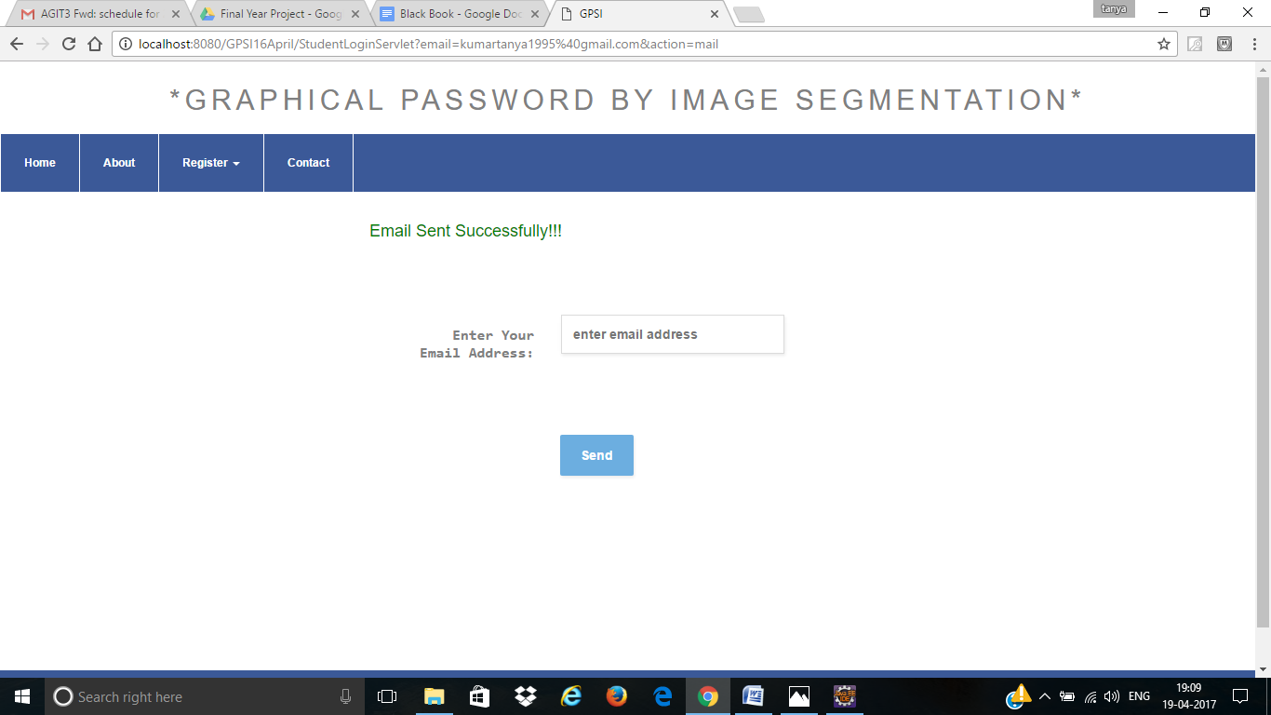

Fig. 6.11 Email sent to the email address

In figure 6.11 shows if the entered username is correct then a link will be mailed to the user.

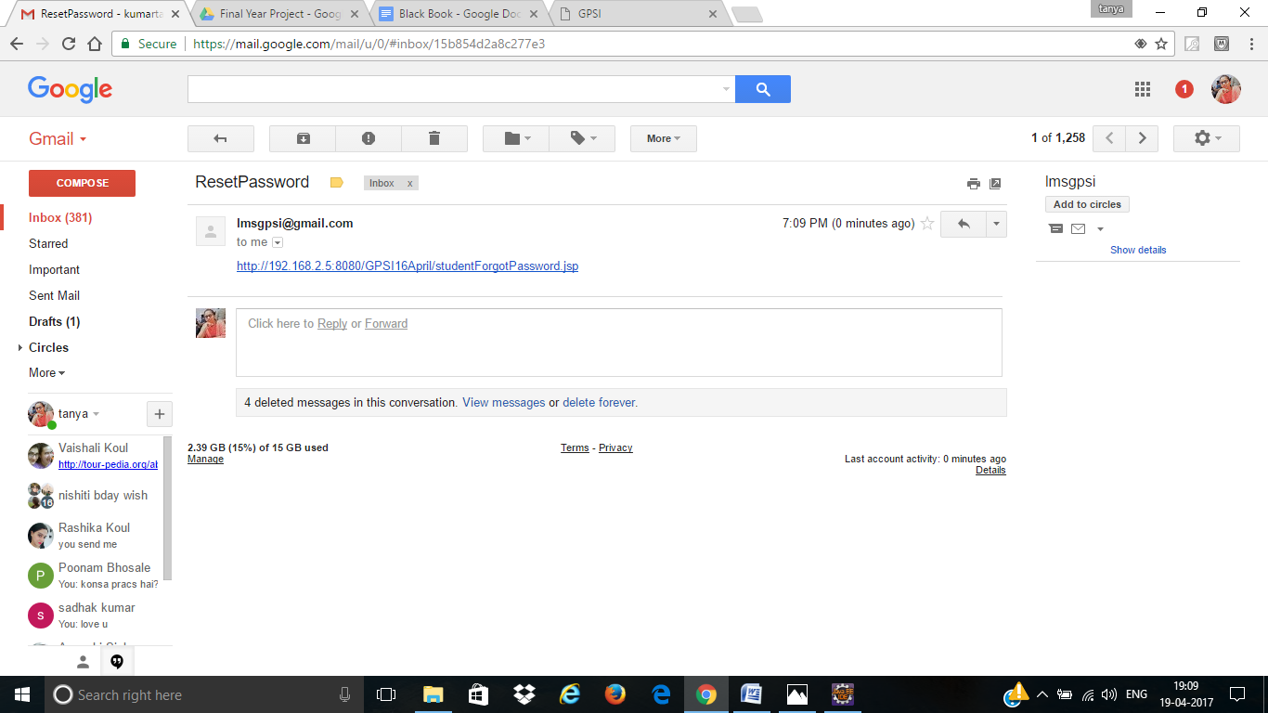

Fig. 6.12 Link received on the user email

In figure 6.12 the user has received the email which has a link for his password.

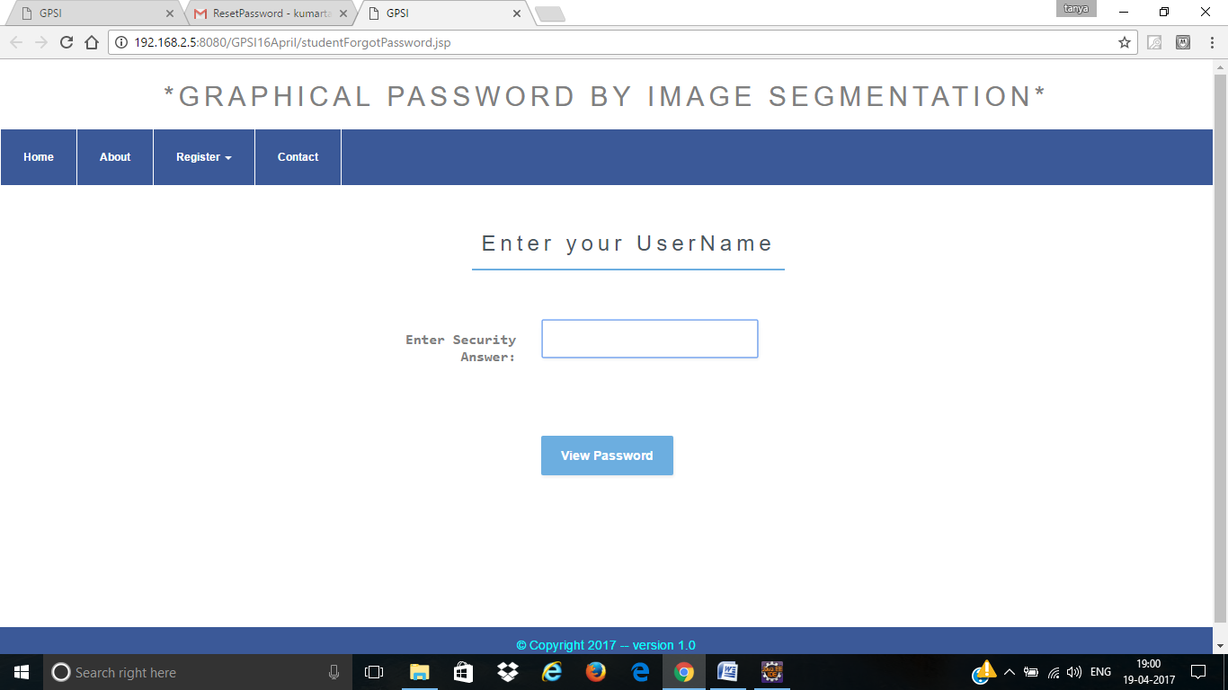

Fig. 6.13 Page after clicking the link

In figure 6.13 shows the page where the user is redirected after clicking on the link. Here the user provides it with his username.

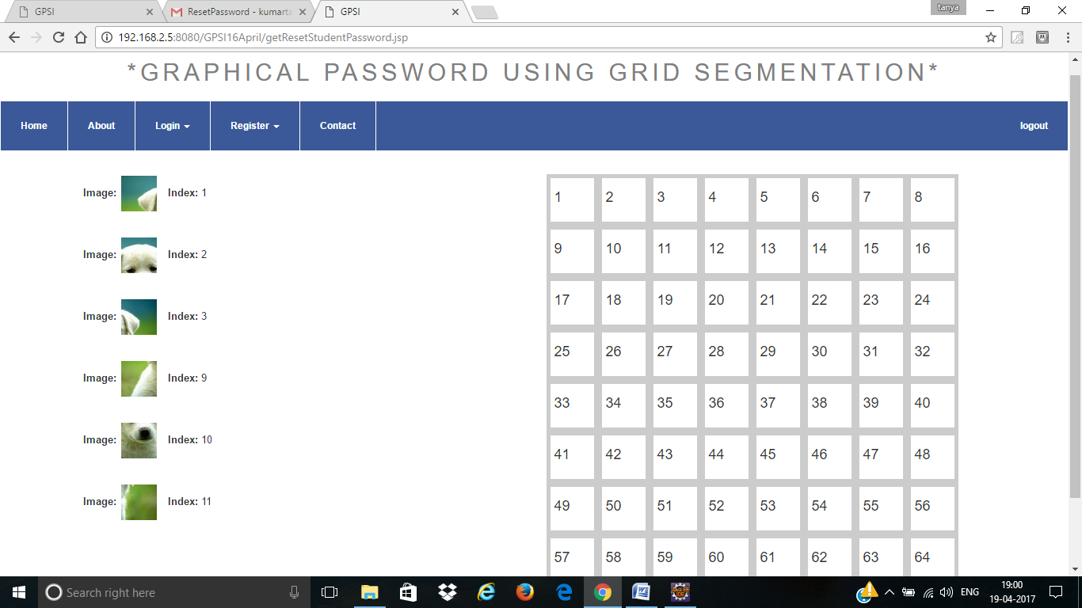

Fig. 6.14 Password shown with proper position and sequence

In figure 6.14 shows the password of the user. The index of each segment with its sequence is displayed to the user.